Grade Two Supply List 2023-2024

- $45.00 school supply fee (if paying by cheque please make payable to Ste. Rose School) Due Friday September 15, 2023.
- Indoor running shoes (non-marking)
- 1 box of Kleenex
- 1 pair of headphones
- Backpack
- Lunch kit
- Water bottle

Thank-you,
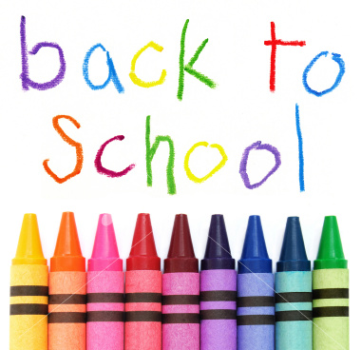
Mrs. Oversby

