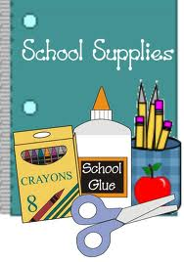
Ste. Rose School Grade One
Supply List 2023-2024

- $45.00 to cover cost of classroom supplies
(cheques may be payable to Ste. Rose School due by September 15, 2023)

- 1 pair of indoor runners non marking soles
(please teach your child to tie their shoes if you are sending tie up laces)

- 1 set of over the ear headphones (not ear buds)
- 1 small water bottle that has a sport lid (one you suck out of)
- 1 box of Kleenex

Thank-you for your cooperation.
Lindsay Lepla
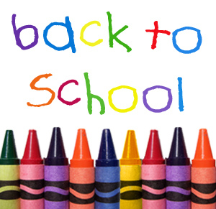
Grade 1 Teacher

